Operational Concept Description (OCD)

E-Lockbox

Team 5

Team Members | Roles
Miles Chen | Project Manager
Azuka Okuleye | Feasibility Analyst
Eric Song | Operational Concept Engineer
Jason Meng | Requirement Engineer
Weiyi Zhong | Prototyper
Kim Woon | System Architecture
Miles Chen | Life-cycle Planer
Cecilia Jou | Quality Focal Point

December 1, 2013

Version History
Date | Author | Version | Changes made | Rationale
09/26/13 | Eric, Miles | 1.0 | - Initial template has been made  - Shared Vision has been added.  - Information on current system has been added  - Section 1, 2 and 3.1 have been completed | - To build operational concepts for team 5 to deliver the e-lockbox system
10/12/13 | Eric | 1.1 | - Revise shared vision  - Section 3.2 have been completed | - To complete all sections based on certain information for foundation phase.
10/14/13 | Eric | 2.0 | - All sections have been completed  - Formats of document are revised | - To fulfill the need of FC package and build a foundation of subsequent development.
10/18/13 | Eric | 2.1 | - Updated Benefits Chain, System Boundary, & Business workflow | - Made corrections based on instructor feedback
12/01/13 | Eric | 3.0 | - Revise System Boundary, & Business workflow | - To be consistent with changed requirements

Table of Contents
Operational Concept Description (OCD) i
Version History ii
Table of Contents iii
Table of Tables iv
Table of Figures v
1. Introduction 1
1.1 Objectives of the OCD 1
1.2 The status of the document 1
2. Shared Vision 2
2.1 Overview of the system 2
2.2 System Boundary and Environment 4
3. System Transformation 5
3.1 Information on Current System 5
3.2 System Objectives, Constraints and Priorities 8
3.3 Proposed New Operational Concept 10
3.4 Organizational and Operational Implications 14

Table of Tables
Table 1: The Program Model 2
Table 2 Artifacts 5
Table 3: Capability Goals 8
Table 4: Level of Service Goals 8
Table 5: Relation to Current System 9

Table of Figures
Figure 1 Benefit Chain Diagram 3
Figure 2 System Boundary and Environment Diagram 4
Figure 3: Enter vital PII and documents workflow 6
Figure 4: Element Relationship Diagram of E-lockbox system 9
Figure 5: Accounts assignment Workflow Diagram 10
Figure 6: Activity logging workflow 11
Figure 7: Report Generation workflow 12

Introduction

Objectives of the OCD
This Operational Concept Description (OCD) provides the shared visions and goals of the stakeholders of e-lockbox system for Living Advantage. The success-critical stakeholders of the project are Pamela R. Clay, as the project owner the Living Advantage staff, foster youth and other public agencies, as users, USC Team 5 as developers and the maintainers.

The status of the document
This is Version 3.0 of the OCD. System boundary diagram and business activity diagram are revised. Some words are also corrected. All sections are complete, ready to be included in the DC package.

Shared Vision

Overview of the system

Table 1: The Program Model
Assumptions

- Foster youth want to have anytime/anywhere electronic access of their vital documents.

Stakeholders | Initiatives | Value Propositions | Beneficiaries
- Developer  - Living Advantage  - Foster youth  - Maintainer | - Develop system  - Partner with public agencies  - Training staff and foster youth to use this system  - Capture data daily and update quarterly  - Increase awareness of this system  - Provide their vital records  - Manage every valid case of foster youth | - Enable identification of foster youth  - Easier access to benefits and services  - Improved information management process  - Better tracking of foster youth  - Saving time, space and cost. | - Foster youth  - Living Advantage

Benefit Chain Diagram

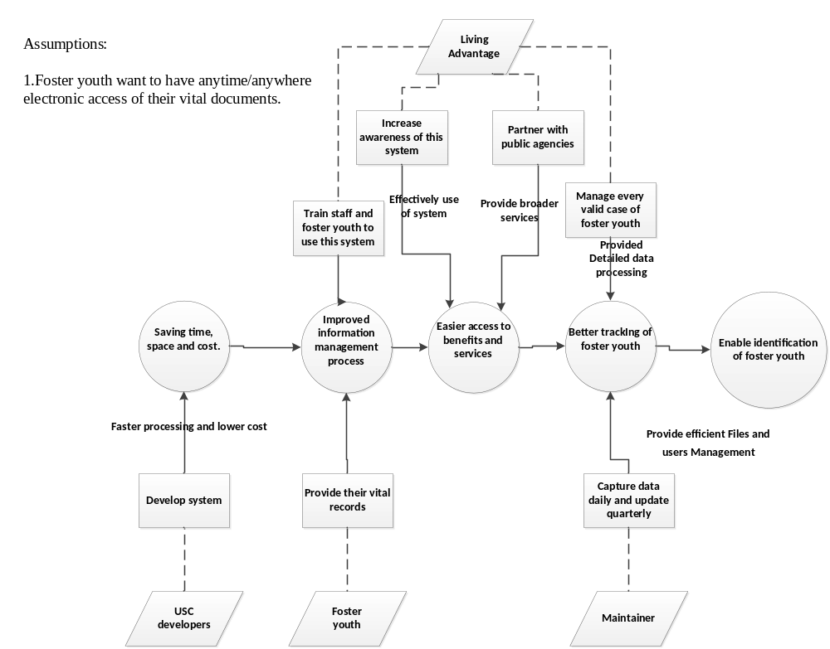
Figure 1 Benefit Chain Diagram

System Boundary and Environment

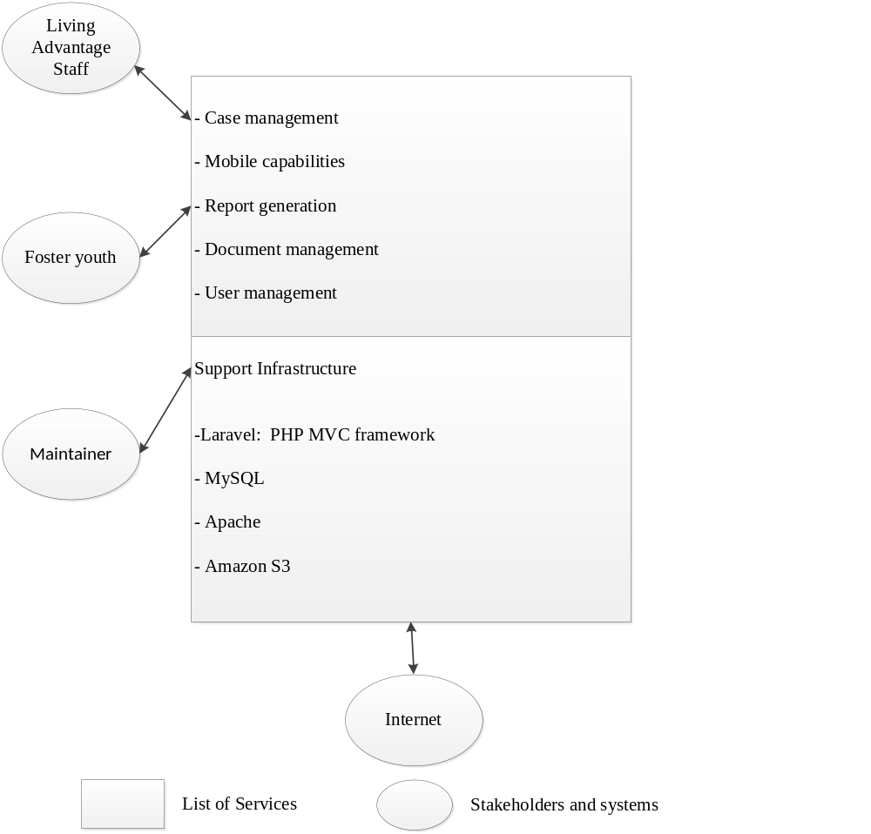
Figure 2 System Boundary and Environment Diagram

System Transformation

Information on Current System

Infrastructure
Living Advantage already has an e-Lockbox system. Currently, the system can provide 3-5 pieces of vital life documents for up to 500 clients. However, it is implemented on Salesforce.com, which is a global cloud computing company, best known for its customer relationship management (CRM) product. Salesforce.com migrated to Dell servers with AMD processors running Linux from Sun Fire E25K servers with SPARC processors running Solaris. Salesforce.com is providing software and hardware support for Living Advantage.

Artifacts

Table 2 Artifacts
Artifact | Description
Current database | Current information of foster youth and their corresponding documents stored in the database.
Background and functional requirements | Introduce the background and big picture of this system and list the functional requirements in a high level.
Documents forms | Templates of online forms.

Current Business Workflow

- Enter vital PII and documents
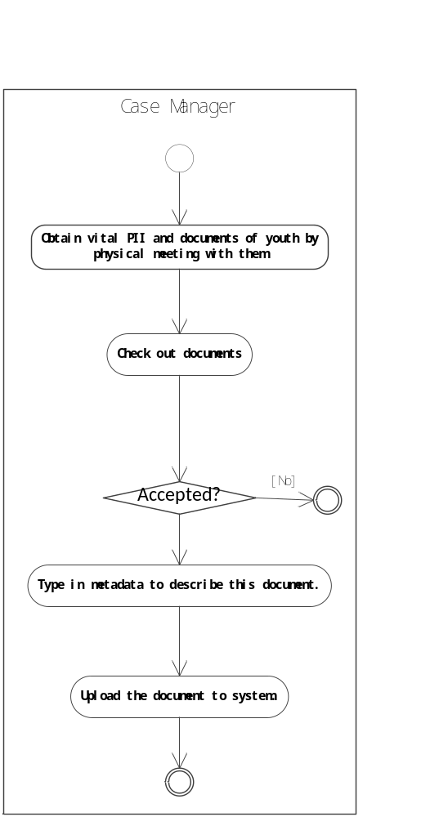
Figure 3: Enter vital PII and documents workflow

System Objectives, Constraints and Priorities

Capability Goals

Table 3: Capability Goals
Capability Goals | Priority Level
OC-1 Document Management: Vital documents for identification can be (i) viewed and printed via accessing the system by foster youth or (ii) scanned and uploaded by case managers or administrators. | Must have
OC-2 Case Management: Case managers can manage related information of cases in their scope | Must have
OC-3 Report Generation: The system is capable of generating the report of demographic information. | Must have
OC-4 User Management: All kinds of users will be managed by administrators. | Must have
OC-5 Character Recognition: The system can extract information from images of vital documents. | Would like

Level of Service Goals
Table 4: Level of Service Goals
Level of Service Goals | Priority Level | Referred WinWin Agreements
LOS-1 Availability: This system should be down no more than 12hrs/monthly | Must have | Win-Condition 2768
LOS-2 Capacity: This system should support at least 5000 users and 5 documents for each. | Must have | Win-Condition 2769
LOS-3 Security: All the documents must be accessed by related authority and cannot be fetched directly from server. | Must have | Win-Condition 2770
LOS-4 Mobile Compatibility: This system should be viewable on mobile devices and have similar GUI. | Should have | Win-Condition 2771

Organizational Goals
OG-: Enable identification of foster youth
OG-2: Easier access to benefits and services
OG-3: Improved information management process and
OG-4: Better tracking of foster youth
OG-5: Saving time, space and cost.

Constraints
No constraints.

Relation to Current System
Table 5: Relation to Current System
Capabilities | Current System | New System
Roles and Responsibilities | Maintained by Salesforce.com | Have Living Advantage staff maintain system including database
User Interactions | Thy system cannot generate demographic information of foster youth. | Case managers can generate demographic information according to their different needs.
Infrastructure | Under the service of Salesforce.com | Living Advantage will have their own software system.
Stakeholder Essentials and Amenities | Current system is a complex and paid, thus difficult to satisfy their specific needs. | Owning their system, they can have specific feature as they want with less money.
Future Capabilities | This system only satisfies the requirements of Living Advantage. | The system will be customized by other public agencies.

Proposed New Operational Concept

Element Relationship Diagram
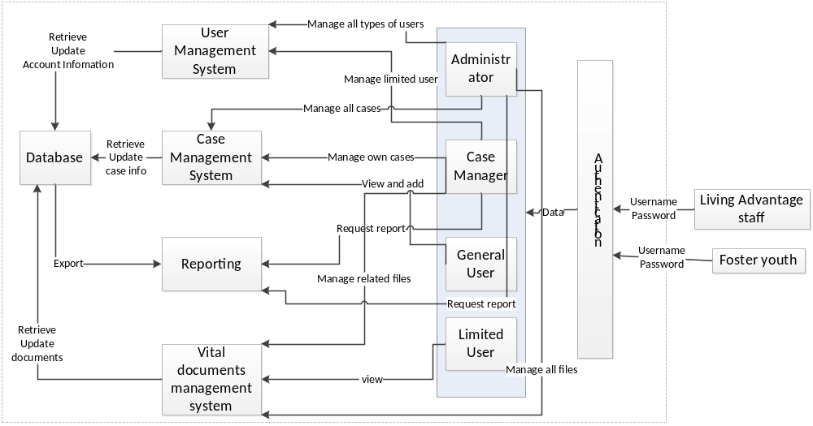
Figure 4: Element Relationship Diagram of E-lockbox system

Business Workflows

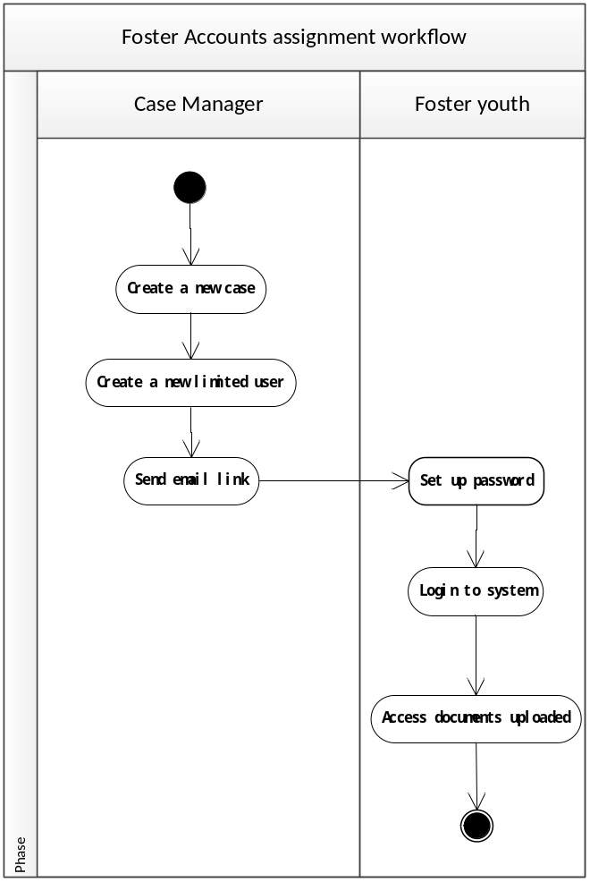
Figure 5: Accounts assignment Workflow Diagram
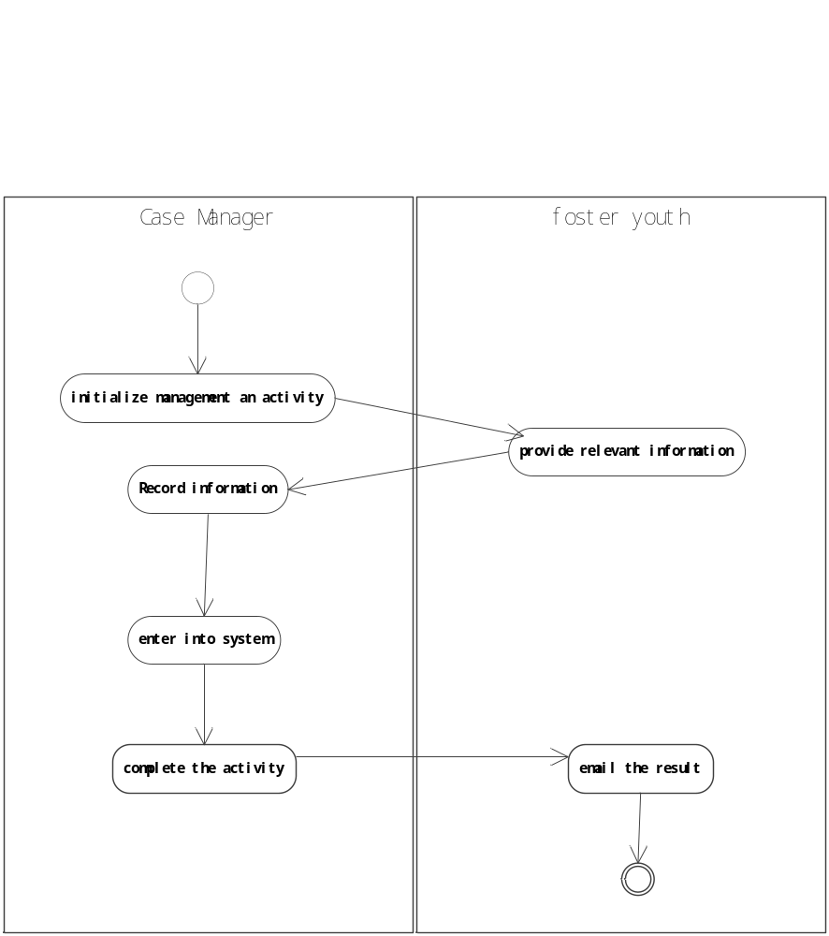
Figure 6: Activity logging workflow

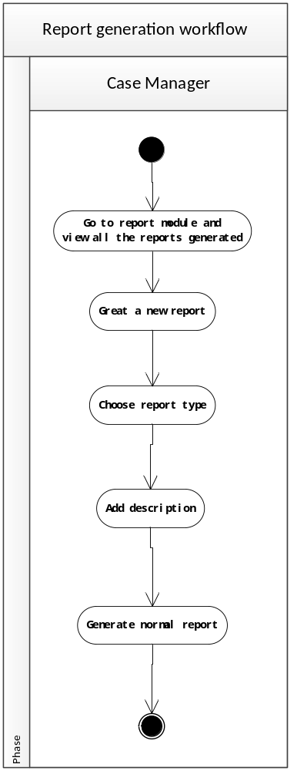
Figure 7: Report Generation workflow

Organizational and Operational Implications

Organizational Transformations
- Living Advantage needs to assign maintainers to take care of the system.
- Living Advantage can be relieved from current, hard-use, time-consuming and limited e-lockbox system.

Operational Transformations
- Foster youth can be assigned accounts to access and view and print their own documents rather than lack the flexibility of managing their own documents.
- Case managers can generate demographic report of foster youth to show positive outcomes.
- General users can also assist to add some information for a case.

